The 10th Annual

Be Electrific Day!
creator and host

Carolyn Finch, MS SLP
Nationally Recognized Body Language Expert & Keynote Speaker

This Event is Free & Open to the public and will include:

Holistic & Health Vendors

Special Edison Displays
“Re-Invent Yourself”, an
Electrific Presentation and
Improv Comedy Team “World Class Indifference” – come laugh with us!
Refreshments and more!!

!!@

When: Sunday February 11, 2007

Time: 3:00 pm to 5:00 pm

Why: To learn how to improve your Health, Performance and Success.

Where: Electrific Learning Centers, 499 Federal Rd, Brookfield CT

Thomas A. Edison
Come Join us at Be Electrific Day
in honor of Thomas A. Edison’s Birthday. His inventions have transformed our world. Come discover the electricity within your own body to prevent stress and illness.

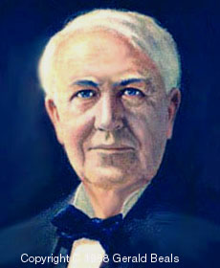

To R.S.V.P. or for more information
Please call Electrific Learning Centers
at 203-775-0290 or email us at carolynf@electrific.com

